|  |  |
| --- | --- |
| Team ID | PNT2022TMID16931 |
| Project Name | Project – News Tracker Application |
| Maximum Marks | 8 Marks |

**SETTING UP APPLICATION ENVIRONMENT**

**CREATE FLASH PROJECT**

**STEP 1: Install python latest version from python.org**

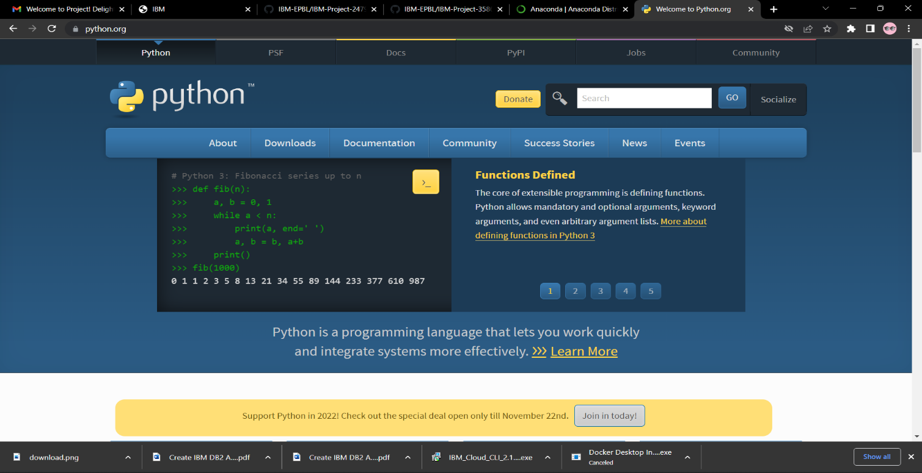

**STEP 2 : Download anaconda from** [**https://www.anaconda.com/**](https://www.anaconda.com/) **and install it .**

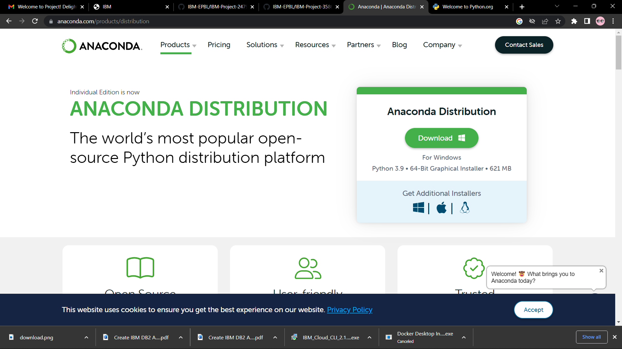

**STEP 3: Install flask using command pip install flask**

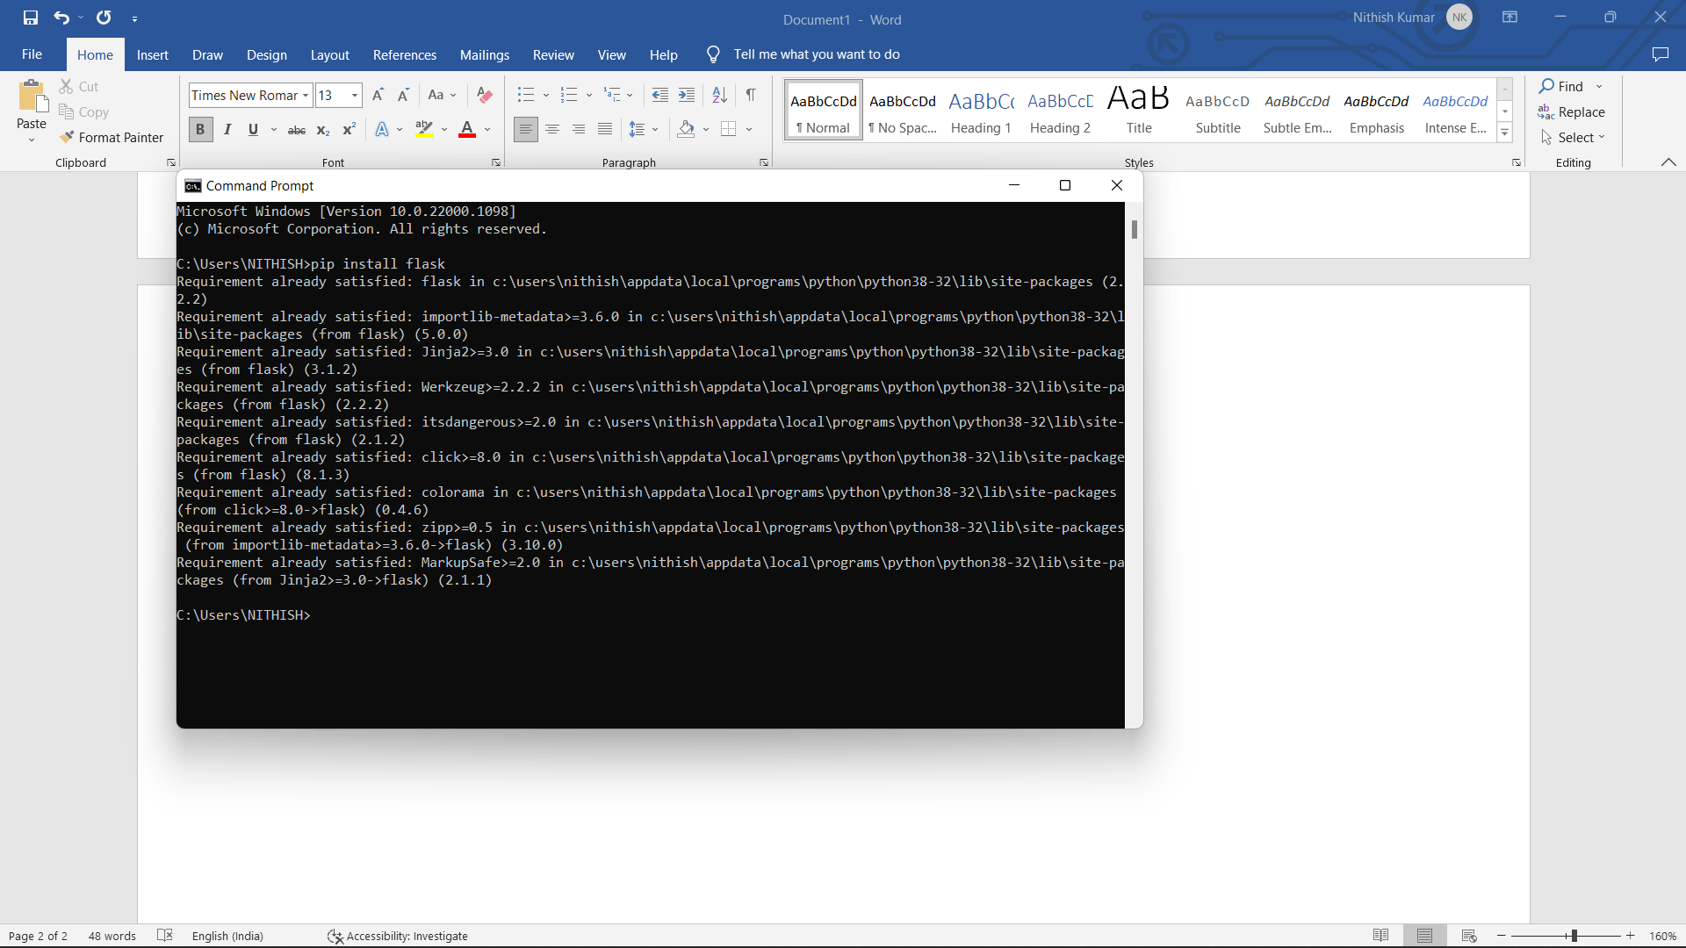

**STEP 4 :Open a new python file and start coding**

From flask import flask app=flask(

name)

@app.route(‘/’)def hello():

Return “hello world”

If name==’main’:

app.run(debug=True)

**STEP 5: Atlast run the python file.**